TITLE: Root Scoop – Fall 2025
SOLEMN WORDS
With the 23rd Memorial recently past, there is not only a wide array of memories, but an even wider array of emotions. This is evident by the pictures, tributes, and words used by those whose experiences ranged from being in Beirut to the family members and friends, who lost someone dear to them. The feelings of loss never seem to leave, and the intensity of them ebbs and flows. As time passes and puts distance between us and the past, the truth of what happened does not. Recently, I rediscovered this poem that was written by Gold Star Mother Mary McCall whose son John was killed that day. John McCall was part of the H&S Company, 1st Battalion, 8th Marines. What makes this particularly special is that this was written by Mary about 2 months after the bombing. We chose not only rewrite the poem, but to leave the poem in its orginal state in the manner it was created at the time.
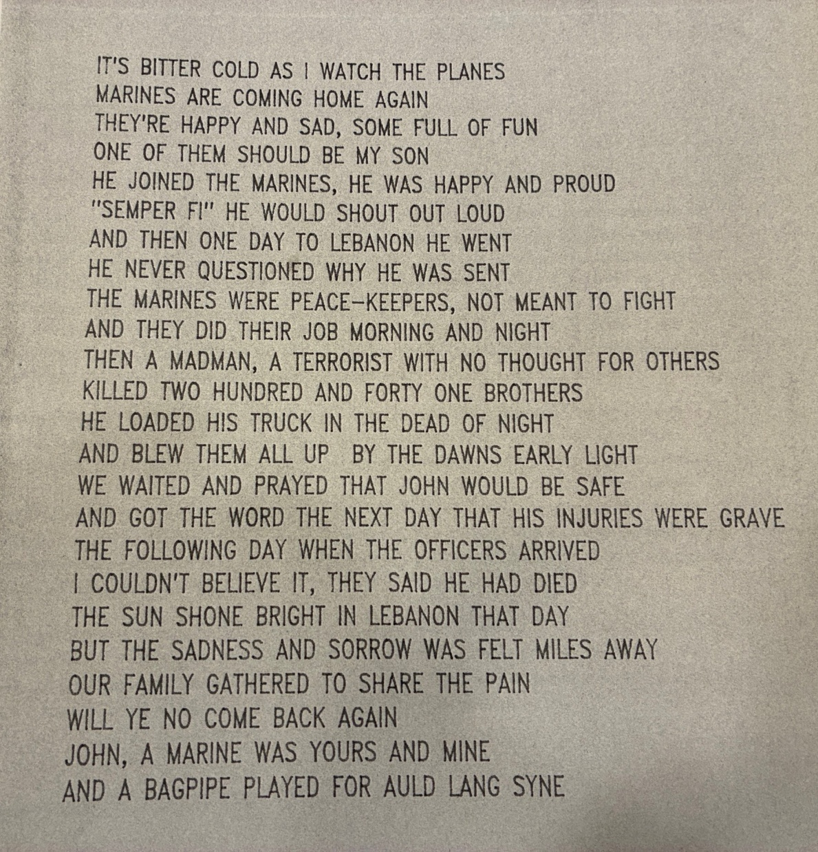
It’s bitter cold as I watch the planes
Marines are coming home again
They’re happy and sad, some full of fun
One of them should be my son
He joined the Marines and should be happy and proud
“Semper Fi” he would shout out loud
And then one day to Lebanon he went
He never questions why he was sent
The Marines were peacekeepers, not sent there to fight
And they did their job morning and night
Then a madman, a terrorist with no thoughts of others
Killed two hundred forty one brothers
He loaded his truck in the dead of night
And blew them all up by dawns early light
We waited and prayed that John would be safe
And got the word the next day that his injuries were grave
The following day when the officers arrived
I couldn’t believe it, they said he died
The sun shown bright in Lebanon that day
But the sadness and sorrow was felt miles away
Our family gathered to share the pain
Will ye no come back again
John, a Marine was yours and mine
And a bag pipe played for Auld Lang Syne

PREPARE, PROMOTE, PRESERVE
The BVA Board is currently discussing the launching of a number of initiatives that will not only increase our awareness, but do something more important, give members an opportunity to be active and make a positive impact on others. As you are aware, this can take a great deal of effort and support
One of the most significant initiatives we chose too perserve the legacy, was to partner with the Carolina Museum of the Marine, which is currently under construction in Jacksonville, NC. The Museum is 25,000 square feet and will honor, preserve and teach the legacy of Carolina Marines and Sailors. In our partnership with them, there will be space allocated to tell the story for posterity. This will not only create an indelible memory, but will also create a central repository for our memories. In the words of Gen. Joseph Shrader (USMC, Ret.) “this is now the home of the BVA.” We anticipate many updates to include there being some material donations offered, but this is part of our broader conversation that are ongoing.
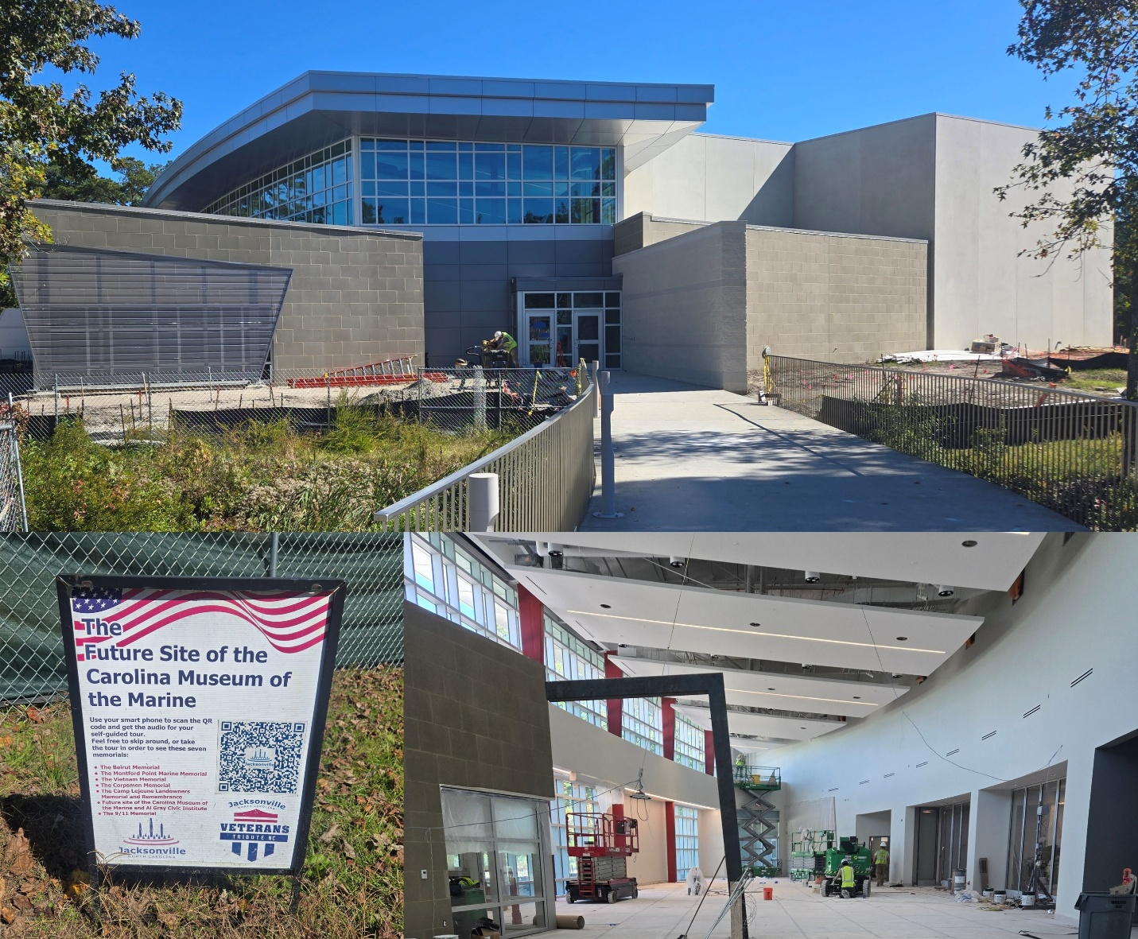

TIME MARCHES FORWARD
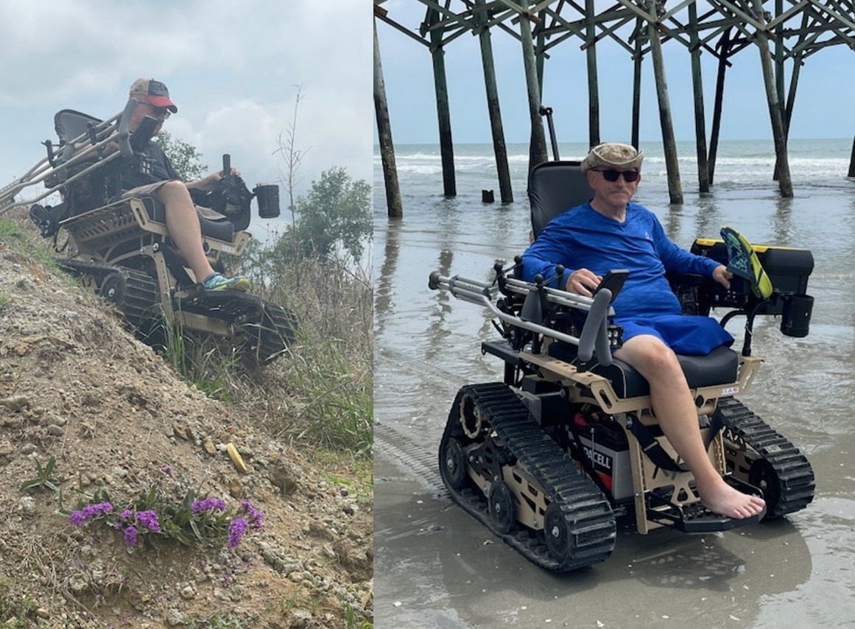
Many of us are facing some type of challenge that is either service related or other issues connected to the normal aging process . . . most of us are also probably in our 60s. The fact is, sometimes these challenges are significant and can keep us from doing the things we like or need to. While a number of us have had knee surgery, Vincent Magaro had his leg amputated above the knee in October 2024. After learning about Action Track Chair from a disabled Army Veteran, he submitted an overview of his condition and in April 2025 was invited to a US Military Vets Motorcycle Club chili cook-off where he was gifted his chair by Roots For Boots a 501c3 based in Hanover, PA. Since that time, Vincent in his usual form is helping champion the awareness of not only the chair, but also this organization. Vincent served in the MSSG 24 and 26 (MEU Service Support Group). Attached you will see pictures of this incredible gift. If you know someone making an impact on the community, please let us know.

BVA SCHOLARSHIP
The BVA scholarship does not only award $1000 to a deserving student, but it is one way to establish caretakers of our story long term. Each year numerous students apply, but at the same time numerous lessons are also taught and embedded for the future. Application starts November 10th and ends January 31st. That said, the following is the scoring criteria and due to the competition, we can’t emphasize how important every point is. The 2025 winner was Chase Hamilton who is now attending the US Air Force Academy and we look forward to getting an update from him in the coming months.
BVA scholarship scoring:
https://www.beirutveterans.org/scholarship-scoring
BVA scholarship details, criteria and process:
https://www.scholarships.com/scholarships/beirut-veterans-of-america-scholarship
NEW MEMBERS
Welcome to the new members. The BVA continues to grow with a wide variety of members from Veterans, Active Duty and Next of Kin. This list presents an opportunity to network and expand the BVA presence regionally. If you would like to connect with one of our members, please reach out to Chip Shields (chip.shields@beirutveterans.org).
We also encourage you to share information about the BVA (link below). To join, go to our website then “Members.”
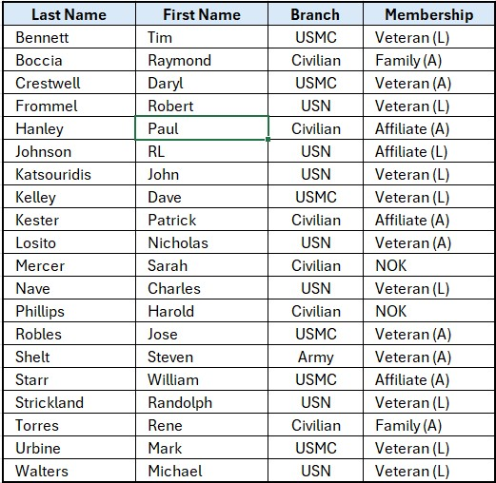
BVA NEWS
In addition to our newsletter, which is both emailed and posted on the website, you can often find news or network online on our official Facebook page.
Beruit Veterans of America Official Group (Facebook):
https://www.facebook.com/groups/53112367708
YOUR STORY
Your stories matter to us, no matter your branch, and we want any and all of them. Over the past two months we have received several If you have an idea, please share with our editor at kevin.macomber at beirutveterans.org.
Root Scoop is the Official newsletter of Beirut Veterans of America. For more information, go to www.beirutveterans.org

